UNIT - III
INTERMEDIATE CODE GENERATION
INTRODUCTION
- In the analysis-synthesis model of a compiler, the front end translates a source program into an intermediate representation from which the back end generates target code.
- Benefits of using a machine-independent intermediate form are:
- Retargeting is facilitated. That is, a compiler for a different machine can be created by attaching a back end for the new machine to an existing front end.
- A machine-independent code optimizer can be applied to the intermediate representation.
3.1 INTERMEDIATE LANGUAGES
- Three ways of intermediate representation:
- Syntax tree
- Postfix notation
- Three address code
- The semantic rules for generating three-address code from common programming language constructs are similar to those for constructing syntax trees or for generating postfix notation.
- Graphical Representations:
3.1.1 Syntax tree: A syntax tree depicts the natural hierarchical structure of a source program.
3.1.2 Directed Acyclic Graph: A DAG gives the same information but in a more compact way because common subexpressions are identified. A syntax tree and dag for the assignment statement a : = b * - c + b * - c are as follows:
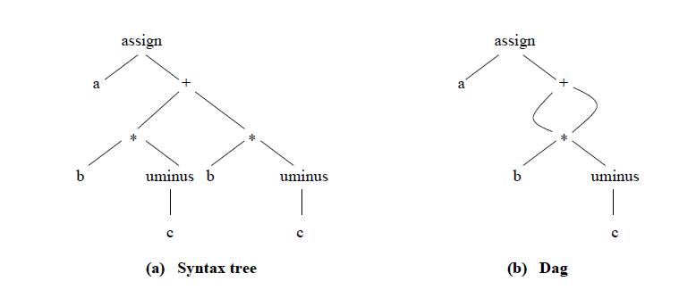
Postfix notation: Postfix notation is a linearized representation of a syntax tree; it is a list of the nodes of the tree in which a node appears immediately after its children. The postfix notation for the syntax tree given above is
a b c uminus * b c uminus * + assign
Syntax-directed definition: Syntax trees for assignment statements are produced by the syntax-directed definition. Non-terminal S generates an assignment statement. The two binary operators + and * are examples of the full operator set in a typical language. Operator associativities and precedences are the usual ones, even though they have not been put into the grammar. This definition constructs the tree from the input a : = b * - c + b* - c.
- The token id has an attribute place that points to the symbol-table entry for the identifier.
- A symbol-table entry can be found from an attribute id.name, representing the lexeme associated with that occurrence of id. If the lexical analyzer holds all lexemes in a single array of characters, then attribute name might be the index of the first character of the lexeme.
- Two representations of the syntax tree are as follows. In (a) each node is represented as a record with a field for its operator and additional fields for pointers to its children. In (b), nodes are allocated from an array of records and the index or position of the node serves as the pointer to the node. All the nodes in the syntax tree can be visited by following pointer s, starting from the root at position 10.
3.1.3 Three-Address Code:
- Three-address code is a sequence of statements of the general form x : = y op z
- where x, y and z are names, constants, or compiler-generated temporaries; op stands for any operator, such as a fixed- or floating-point arithmetic operator, or a logical operator on Boolean valued data.
- The source language expression like x+ y*z might be translated into a sequence
t1 : = y * z
t2 : = x + t1
Where t1 and t2 are compiler-generated temporary names.
Advantages of three-address code:
- The unraveling of complicated arithmetic expressions and of nested flow-of-control statements makes three-address code desirable for target code generation and optimization.
- The use of names for the intermediate values computed by a program allows three address code to be easily rearranged – unlike postfix notation.
- Three-address code is a linearized representation of a syntax tree or a dag in which explicit names correspond to the interior nodes of the graph. The syntax tree and dag are represented by the three-address code sequences. Variable names can appear directly in three address statements.
Three-address code corresponding to the syntax tree and dag given above
t1 : = - c t1 : = -c
t2 : = b * t1 t2 : = b * t1
t3 : = - c t5 : = t2 + t2
t4 : = b * t3 a : = t5
t5 : = t2 + t4
a : = t5
(a) Code for the syntax tree (b) Code for the dag
- The reason for the term “three-address code” is that each statement usually contains three addresses, two for the operands and one for the result.
Types of Three-Address Statements:
- The common three-address statements are:
- Assignment statements of the form x : = y op z, where op is a binary arithmetic or logical operation.
- Assignment instructions of the form x : = op y, where op is a unary operation. Essential unary operations include unary minus, logical negation, shift operators, and conversion operators that, for example, convert a fixed-point number to a floating-point number.
- Copy statements of the form x : = y where the value of y is assigned to x.
- The unconditional jump goto L. The three-address statement with label L is the next to be executed.
- Conditional jumps such as if x relop y goto L. This instruction applies a relational operator (<, =, >=, etc. ) to x and y, and executes the statement with label L next if x stands in relation relop to y. If not, the three-address statement following if x relop y goto L is executed next, as in the usual sequence.
- param x and call p, n for procedure calls and return y, where y representing a returned value is optional.
For example,
param x1
param x2
. . .
param xn
call p,n
generated as part of a call of the procedure p(x1, x2, …. ,xn ).
- Indexed assignments of the form x : = y[i] and x[i] : = y.
- Address and pointer assignments of the form x : = &y , x : = *y, and *x : = y.

Implementation of Three-Address Statements:
- A three-address statement is an abstract form of intermediate code. In a compiler, these statements can be implemented as records with fields for the operator and the operands.
- Three such representations are:
- Quadruples
- Triples
- Indirect triples
Quadruples:
- A quadruple is a record structure with four fields, which are, op, arg1, arg2 and result.
- The op field contains an internal code for the operator. The three-address statement x : = y op z is represented by placing y in arg1, z in arg2 and x in result.
- The contents of fields arg1, arg2 and result are normally pointers to the symbol-table entries for the names represented by these fields. If so, temporary names must be entered into the symbol table as they are created.
Triples:
- To avoid entering temporary names into the symbol table, we might refer to a temporary value by the position of the statement that computes it.
- If we do so, three-address statements can be represented by records with only three fields: op, arg1 and arg2.
- The fields arg1 and arg2, for the arguments of op, are either pointers to the symbol table or pointers into the triple structure (for temporary values ).
- Since three fields are used, this intermediate code format is known as triples.

Example: Convert into Quadruples, Triples and Indirect Triples for the expression a=b*-c+b*-c.
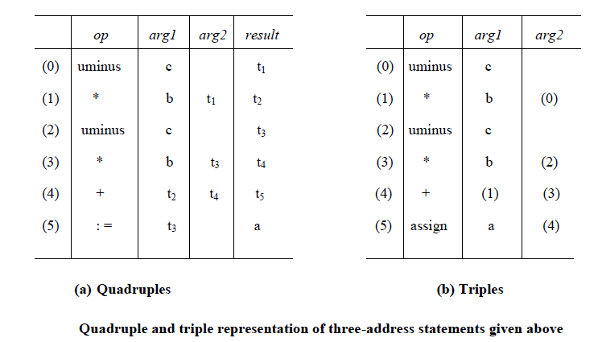
Indirect Triples:
- Another implementation of three-address code is that of listing pointers to triples, rather than listing the triples themselves. This implementation is called indirect triples.
- For example, let us use an array statement to list pointers to triples in the desired order. Then the triples shown above might be represented as follows:
- A ternary operation like x[i] : = y requires two entries in the triple structure as shown as below while x : = y[i] is naturally represented as two operations.

3.2 DECLARATIONS:
- As the sequence of declarations in a procedure or block is examined, we can lay out storage for names local to the procedure.
- For each local name, we create a symbol-table entry with information like the type and the relative address of the storage for the name.
- The relative address consists of an offset from the base of the static data area or the field for local data in an activation record.
Declarations in a Procedure:
- The syntax of languages such as C, Pascal and Fortran, allows all the declarations in a single procedure to be processed as a group. In this case, a global variable, say offset, can keep track of the next available relative address.
- In the translation scheme shown below:
- Nonterminal P generates a sequence of declarations of the form id:T.
- Before the first declaration is considered, offset is set to 0. As each new name is seen, that name is entered in the symbol table with offset equal to the current value of offset, and offset is incremented by the width of the data object denoted by that name.
- The procedure enter( name, type, offset ) creates a symbol-table entry for name, gives its type type and relative address offset in its data area.
- Attribute type represents a type expression constructed from the basic types integer and real by applying the type constructors pointer and array. If type expressions are represented by graphs, then attribute type might be a pointer to the node representing a type expression.
- The width of an array is obtained by multiplying the width of each element by the number of elements in the array. The width of each pointer is assumed to be 4.

3.3 ASSIGNMENT STATEMENTS
- Suppose that the context in which an assignment appears is given by the following grammar.
P M D
M ɛ
D D ; D | id : T | proc id ; N D ; S
N ɛ
Nonterminal P becomes the new start symbol when these productions are added to those in the translation scheme shown below.
Reusing Temporary Names
- The temporaries used to hold intermediate values in expression calculations tend to clutter up the symbol table, and space has to be allocated to hold their values.
- Temporaries can be reused by changing newtemp. The code generated by the rules for E
E1 + E2 has the general form:
evaluate E1 into t1
evaluate E2 into t2
t : = t1 + t2
- The lifetimes of these temporaries are nested like matching pairs of balanced parentheses.
- Keep a count c, initialized to zero. Whenever a temporary name is used as an operand, decrement c by 1. Whenever a new temporary name is generated, use $c and increase c by 1.
- For example, consider the assignment x := a * b + c * d – e * f
Addressing Array Elements:
- Elements of an array can be accessed quickly if the elements are stored in a block of consecutive locations. If the width of each array element is w, then the ith element of array A begins in location
base + ( i – low ) x w
- where low is the lower bound on the subscript and base is the relative address of the storage allocated for the array. That is, base is the relative address of A[low].
- The expression can be partially evaluated at compile time if it is rewritten as
i x w + ( base – low x w)
- The subexpression c = base – low x w can be evaluated when the declaration of the array is seen.
- We assume that c is saved in the symbol table entry for A , so the relative address of A[i] is obtained by simply adding i x w to c.

3.4 BOOLEAN EXPRESSIONS
- Boolean expressions have two primary purposes. They are used to compute logical values, but more often they are used as conditional expressions in statements that alter the flow of control, such as if-then-else, or while-do statements.
- Boolean expressions are composed of the boolean operators ( and, or, and not ) applied to elements that are boolean variables or relational expressions. Relational expressions are of the form E1 relop E2, where E1 and E2 are arithmetic expressions.
- Here we consider boolean expressions generated by the following grammar :
E E or E | E and E | not E | ( E ) | id relop id | true | false
Methods of Translating Boolean Expressions:
- There are two principal methods of representing the value of a boolean expression. They are :
- To encode true and false numerically and to evaluate a boolean expression analogously to an arithmetic expression. Often, 1 is used to denote true and 0 to denote false.
- To implement boolean expressions by flow of control, that is, representing the value of a boolean expression by a position reached in a program. This method is particularly convenient in implementing the boolean expressions in flow-of-control statements, such as the if-then and while-do statements.
Numerical Representation
- Here, 1 denotes true and 0 denotes false. Expressions will be evaluated completely from left to right, in a manner similar to arithmetic expressions.
- For example:
- which can be translated into the three-address code sequence (again, we arbitrarily start statement numbers at 100) :
100 : if a < b goto 103
101 : t : = 0
102 : goto 104
103 : t : = 1
104 :
Short-Circuit Code:
- We can also translate a boolean expression into three-address code without generating code for any of the boolean operators and without having the code necessarily evaluate the entire expression. This style of evaluation is sometimes called “short-circuit” or “jumping” code.
- It is possible to evaluate boolean expressions without generating code for the boolean operators and, or, and not if we represent the value of an expression by a position in the code sequence.

Flow-of-Control Statements
- We now consider the translation of boolean expressions into three-address code in the context of if-then, if-then-else, and while-do statements such as those generated by the following grammar:
S if E then S1
| if E then S1 else S2
| while E do S1
- In each of these productions, E is the Boolean expression to be translated. In the translation, we assume that a three-address statement can be symbolically labeled, and that the function newlabel returns a new symbolic label each time it is called.
- E.true is the label to which control flows if E is true, and E.false is the label to which control flows if E is false.
- The semantic rules for translating a flow-of-control statement S allow control to flow from the translation S.code to the three-address instruction immediately following S.code.
- S.next is a label that is attached to the first three-address instruction to be executed after the code for S.

3.5 CASE STATEMENTS
- The “switch” or “case” statement is available in a variety of languages. The switch-statement syntax is as shown below:
Switch-statement syntax
switch expression
begin
case value : statement
case value : statement
. . .
case value : statement
default : statement
end
- There is a selector expression, which is to be evaluated, followed by n constant values that the expression might take, including a default “value” which always matches the expression if no other value does. The intended translation of a switch is code to:
- Evaluate the expression.
- Find which value in the list of cases is the same as the value of the expression.
- Execute the statement associated with the value found.
- Step (2) can be implemented in one of several ways :
- By a sequence of conditional goto statements, if the number of cases is small.
- By creating a table of pairs, with each pair consisting of a value and a label for the code of the corresponding statement. Compiler generates a loop to compare the value of the expression with each value in the table. If no match is found, the default (last) entry is sure to match.
- If the number of cases s large, it is efficient to construct a hash table.
- There is a common special case in which an efficient implementation of the n-way branch exists. If the values all lie in some small range, say imin to imax, and the number of different values is a reasonable fraction of imax - imin, then we can construct an array of labels, with the label of the statement for value j in the entry of the table with offset j -imin and the label for the default in entries not filled otherwise. To perform switch,evaluate the expression to obtain the value of j, check the value is within range and transfer to the table entry at offset j-imin .

Syntax-Directed Translation of Case Statements:
Consider the following switch statement:
switch E
begin
case V1 : S1
case V2 : S2
. . .
case Vn-1 : Sn-1
default : Sn
end
This case statement is translated into intermediate code that has the following form :
Translation of a case statement
To translate into above form:
- When keyword switch is seen, two new labels test and next, and a new temporary t are generated.
- As expression E is parsed, the code to evaluate E into t is generated. After processing E , the jump goto test is generated.
- As each case keyword occurs, a new label Li is created and entered into the symbol table.
- A pointer to this symbol-table entry and the value Vi of case constant are placed on astack (used only to store cases).
- Each statement case Vi : Si is processed by emitting the newly created label Li, followed by the code for Si , followed by the jump goto next.
- Then when the keyword end terminating the body of the switch is found, the code can be generated for the n-way branch. Reading the pointer-value pairs on the case stack from the bottom to the top, we can generate a sequence of three-address statements of the form
case V1 L1
case V2 L2
. . .
case Vn-1 Ln-1
case t Ln
label next
where t is the name holding the value of the selector expression E, and Ln is the label for the default statement.

3.6 BACKPATCHING
- The easiest way to implement the syntax-directed definitions for boolean expressions is to use two passes. First, construct a syntax tree for the input, and then walk the tree in depth-first order, computing the translations. The main problem with generating code for Boolean expressions and flow-of-control statements in a single pass is that during one single pass we may not know the labels that control must go to at the time the jump statements are generated. Hence, a series of branching statements with the targets of the jumps left unspecified is generated. Each statement will be put on a list of goto statements whose labels will be filled in when the proper label can be determined. We call this subsequent filling in of labels backpatching.
- To manipulate lists of labels, we use three functions :
- makelist(i) creates a new list containing only i, an index into the array of quadruples;makelist returns a pointer to the list it has made.
- merge(p1,p2) concatenates the lists pointed to by p1 and p2, and returns a pointer to the concatenated list.
- backpatch(p,i) inserts i as the target label for each of the statements on the list pointed to by p.
3.7 Flow-of-Control Statements:
- A translation scheme is developed for statements generated by the following grammar :
(1) S if E then S
(2) | if E then S else S
(3) | while E do S
(4) | begin L end
(5) | A
(6) L L ; S
(7) | S
- Here S denotes a statement, L a statement list, A an assignment statement, and E a Boolean expression. We make the tacit assumption that the code that follows a given statement in execution also follows it physically in the quadruple array. Else, an explicit jump must be provided.
Scheme to implement the Translation:
- The nonterminal E has two attributes E.truelist and E.falselist. L and S also need a list of unfilled quadruples that must eventually be completed by backpatching. These lists are pointed to by the attributes L..nextlist and S.nextlist. S.nextlist is a pointer to a list of all conditional and unconditional jumps to the quadruple following the statement S in execution order, and L.nextlist is defined similarly.
- The semantic rules for the revised grammar are as follows:
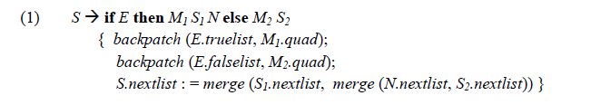
- The backpatch the jumps when E is true to the quadruple M1.quad, which is the beginning of the code for S1. Similarly, we backpatch jumps when E is false to go to the beginning of the code for S2. The list S.nextlist includes all jumps out of S1 and S2, as well as the jump generated by N.

3.8 PROCEDURE CALLS
- The procedure is such an important and frequently used programming construct that it is imperative for a compiler to generate good code for procedure calls and returns. The run-time routines that handle procedure argument passing, calls and returns are part of the run-time support package.
- Let us consider a grammar for a simple procedure call statement
(1) S call id ( Elist )
(2) Elist Elist , E
(3) Elist E
Calling Sequences:
- The translation for a call includes a calling sequence, a sequence of actions taken on entry to and exit from each procedure. The falling are the actions that take place in a calling sequence.
- When a procedure call occurs, space must be allocated for the activation record of the called procedure.
- The arguments of the called procedure must be evaluated and made available to the called procedure in a known place.
- Environment pointers must be established to enable the called procedure to access data in enclosing blocks.
- The state of the calling procedure must be saved so it can resume execution after the call.
- Also saved in a known place is the return address, the location to which the called routine must transfer after it is finished.
- Finally a jump to the beginning of the code for the called procedure must be generated.
- For example, consider the following syntax-directed translation
(1) S call id ( Elist )
{ for each item p on queue do
emit (‘ param’ p );
emit (‘call’ id.place) }
(2) Elist Elist , E
{ append E.place to the end of queue }
(3) Elist E
{ initialize queue to contain only E.place }
- Here, the code for S is the code for Elist, which evaluates the arguments, followed by a param p statement for each argument, followed by a call statement.
- queue is emptied and then gets a single pointer to the symbol table location for the name that denotes the value of E.

